**Sivacoin - A cryptocurrency**

- P.Vignesh Siva

# **Sivacoin:**

Sivacoin is a cryptocurrency developed using blockchain technology in python programming language. The blockchain is developed to run in a single system, later an additional function is added to distribute the blockchain to multiple nodes. Each connected system can mine a block to add the transactions into the blockchain. These blocks are created using proof of work protocol and the blockchain is validated by the longest chain selection consensus protocol.

# **Creating a blockchain:**

Blockchain is created using Flask library in python programming language. This flask application contains the api calls to mine a new block and view the whole blockchain.

Mining a new block 1

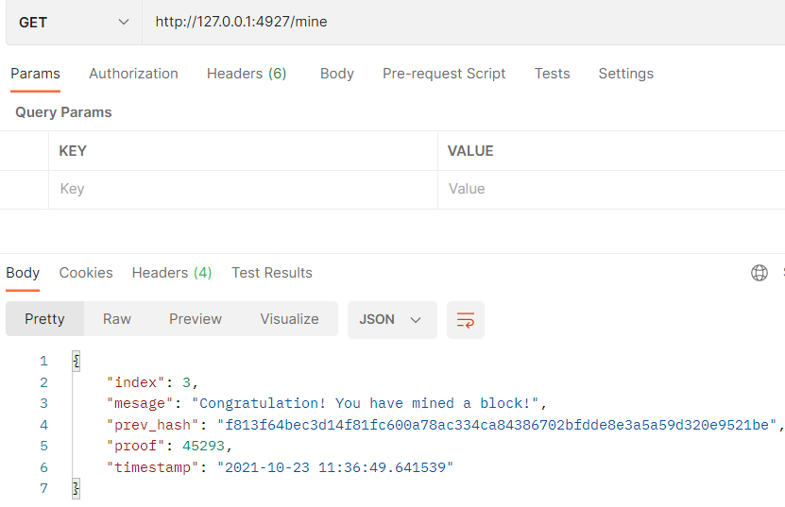

Displaying our blockchain 1

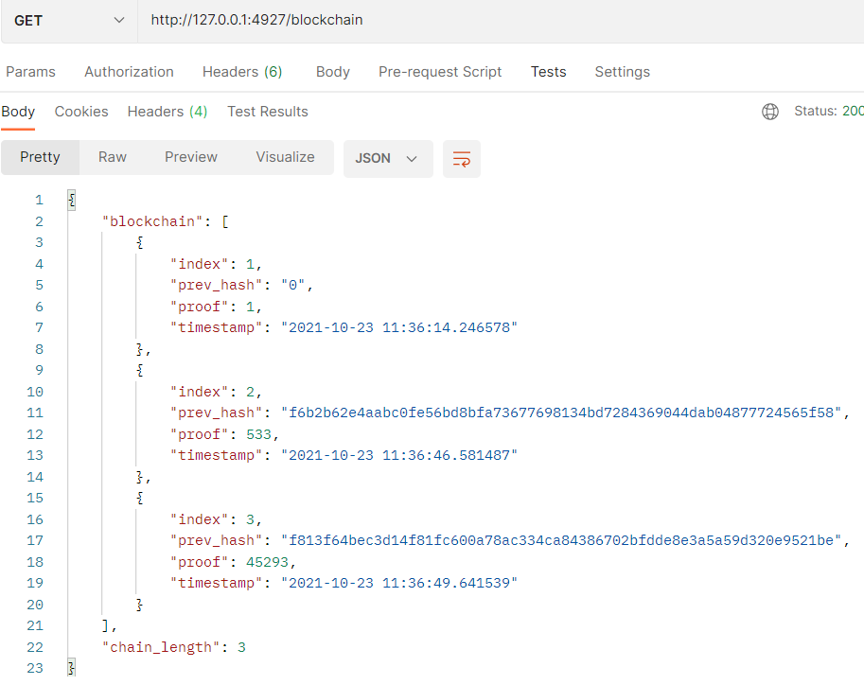

# **Decentralizing the blockchain:**

Multiple copies of blockchain application are created and ran these 3 files in 3 different ports. Each node can individually mine a block and create a blockchain. Also these nodes can connect with each other to form a distributed network and mine blocks to add the transactions.

Connecting nodes to network 1

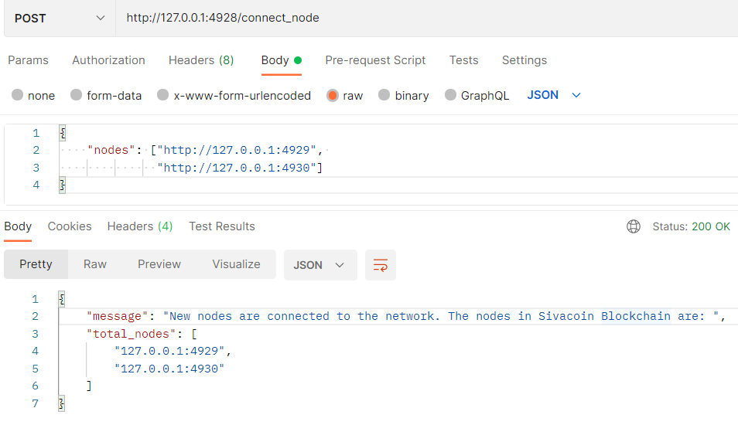

# **Adding transaction to blockchain:**

New transactions are added to a new block by the add_tranxaction function.

Adding transaction to blockchain 1

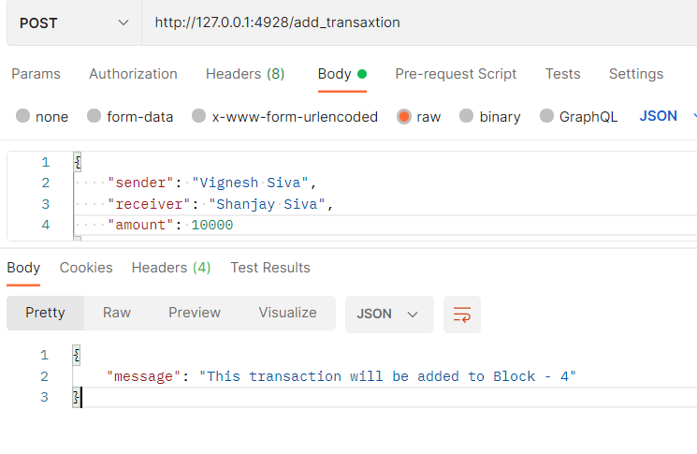

# **Replacing chain by longest chain:**

A new block is mined by a node to include the transactions. The node which has the longest chain length dominates. The replace_chain function finds the longest chain and replaces the current chain with that longest chain

Replacing chain by longest chain 1

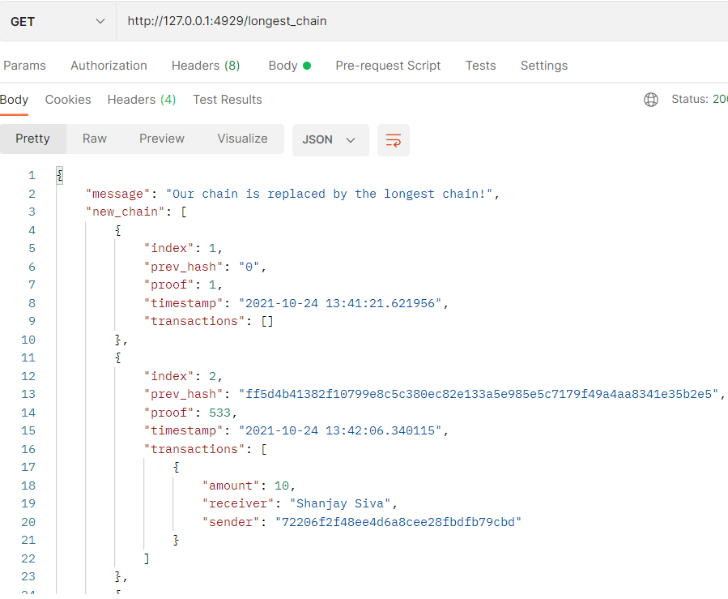

# **Postman for api calls:**

I have used postman for all api calls which executes the specified functions such as mine block, view the chain, connect nodes, add transaction and replace chain by longest chain.